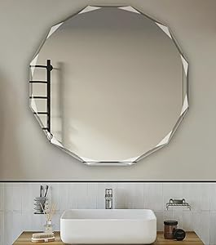

$155

Single Beveled Edge Circle Mirror Frameless Wall Mount Bathroom Vanity Mirror, 20”